17 May 2020

Began a new project to sift out the problems of 411. Updated all Nuget packages right away.

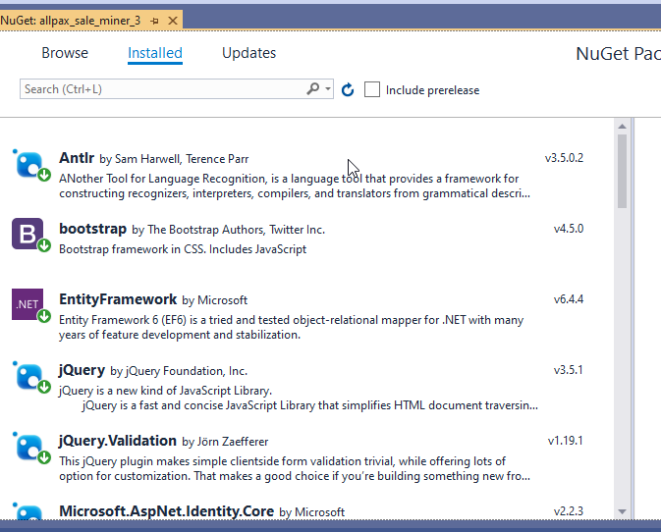

Got the navbar layout set up.

